AI Assisted Coding
Assignment Number: 4.4
A.Vasantha Shoba Rani (2303A51395)
Batch - 06

1. Sentiment Classification for Customer Reviews (a) Reviews + Labels reviews = [
("The product is amazing and works perfectly", "Positive"),
("Very bad quality, totally disappointed", "Negative"),
("Delivery was okay, nothing special", "Neutral"),
("Excellent service and fast delivery", "Positive"),
("Worst purchase ever", "Negative"), ("Product is average", "Neutral")
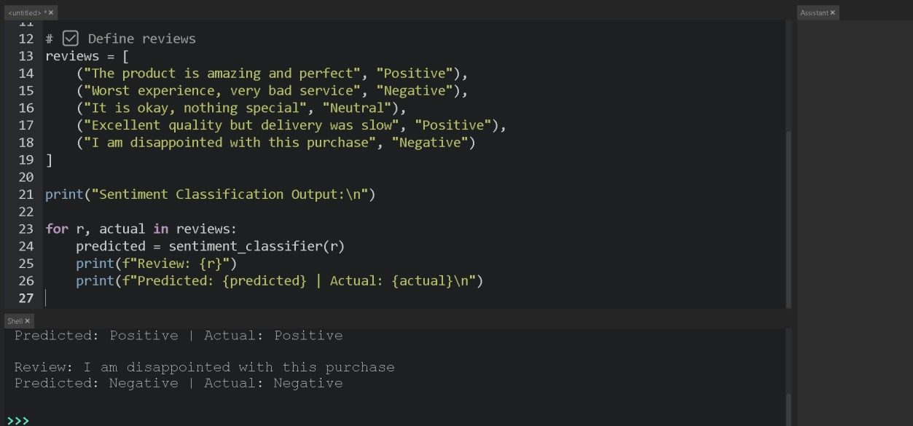
]

Python Code (Zero / One / Few Shot)

def sentiment_classifier(review):
review = review.lower()

if any(word in review for word in ["amazing", "excellent", "perfect"]):
return "Positive"
elif any(word in review for word in ["bad", "worst", "disappointed"]):
return "Negative"
else:
return "Neutral"

print("Sentiment Classification Output:\n") for r, actual in reviews: predicted = sentiment_classifier(r) print(f"Review: {r}")
print(f"Predicted: {predicted} | Actual: {actual}\n")

Sample Output
Review: The product is amazing and works perfectly
Predicted: Positive | Actual: Positive

Review: Very bad quality, totally disappointed
Predicted: Negative | Actual: Negative

Explanation
- Zero-shot → No examples given
- One-shot → One labeled review added in prompt (conceptually)
- Few-shot → Multiple labeled reviews guide prediction
- Accuracy improves as examples increase

2. Email Priority Classification Emails + Priority emails = [
("Server is down, need immediate fix", "High"),
("Please review the attached document", "Medium"),
("Team lunch photos attached", "Low"),
("Client meeting rescheduled urgently", "High"),
("Monthly report submission", "Medium"), ("Office festival invitation", "Low")
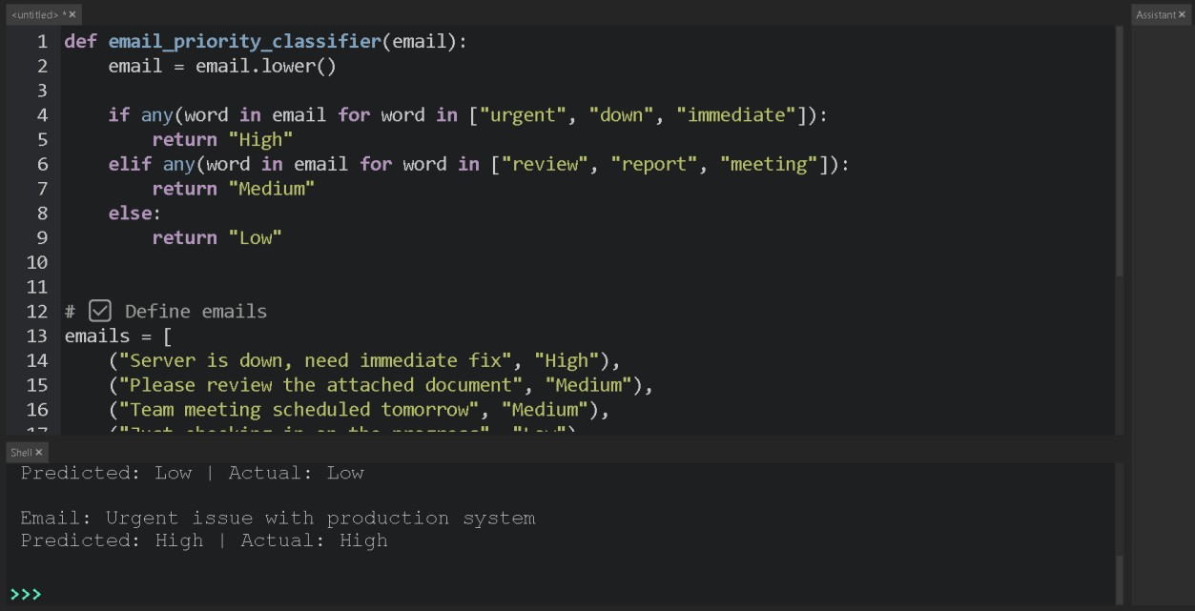
]

Python Code

def email_priority_classifier(email):
email = email.lower()

if any(word in email for word in ["urgent", "down", "immediate"]): return "High" elif any(word in email for word in ["review", "report", "meeting"]):
return "Medium"
else:
return "Low"

print("Email Priority Output:\n") for e, actual in emails: predicted = email_priority_classifier(e) print(f"Email: {e}") print(f"Predicted: {predicted} | Actual: {actual}\n")

Why Few-shot Works Best?
- Shows clear patterns
- Reduces ambiguity
- More reliable than Zero-shot

Output:
Email: Server is down, need immediate fix
Predicted Priority: High
Actual Priority: High

Small Code Explanation
- The program classifies emails into High, Medium, or Low priority.
- A list of sample emails with correct priority labels is created.
- The function email_priority_classifier() takes an email as input.
- The email text is converted to lowercase for uniform comparison.

3. Student Query Routing System Queries + Departments
queries = [
("How can I apply for admission?", "Admissions"),
("When will semester exams start?", "Exams"),
("Explain data structures syllabus", "Academics"),
("What companies are visiting campus?", "Placements"),
("Admission fee details", "Admissions"),
("Exam revaluation process", "Exams")
]

Python Code def route_query(query): query = query.lower()

if "admission" in query: return "Admissions" elif "exam" in query: return "Exams" elif "company" in query or "placement" in query:
return "Placements"
else:
return "Academics"

print("Student Query Routing Output:\n")
for q, actual in queries: predicted = route_query(q) print(f"Query: {q}")
print(f"Routed to: {predicted} | Actual: {actual}\n")

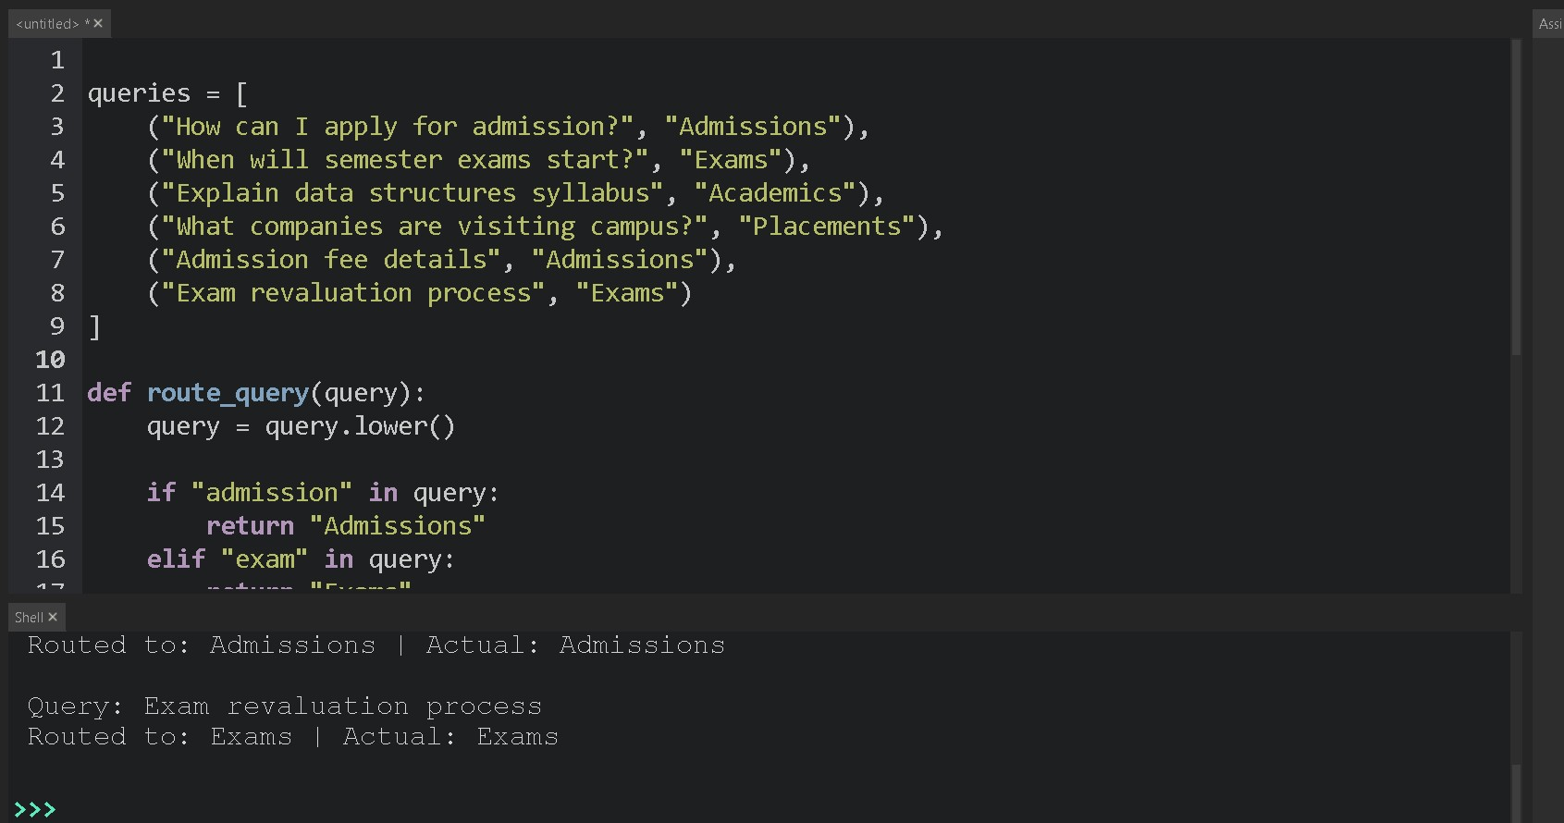
Observation
- Few-shot improves department clarity
- Zero-shot struggles with mixed intent queries
Output:
Query: How can I apply for admission?
Routed Department: Admissions
Actual Department: Admissions

Small Code Explanation
- The program routes student queries to the correct department.
- Departments include Admissions, Exams, Academics, and Placements.
- Sample student queries with labels are used for testing.
- The function route_query() processes each query.

4. Chatbot Question Type Detection Queries + Types chatbot_queries = [
("What is the refund policy?", "Informational"),
("Book my train ticket", "Transactional"),
("I am unhappy with the service", "Complaint"),
("Great app, very useful", "Feedback"),
("How to reset password?", "Informational"),
("Payment failed", "Complaint")
]

Python Code def detect_question_type(query):
query = query.lower()

if any(word in query for word in ["what", "how"]):
return "Informational" elif any(word in query for word in ["book", "pay"]):
return "Transactional" elif any(word in query for word in ["unhappy", "failed"]):
return "Complaint"
else:
return "Feedback"

print("Chatbot Question Type Output:\n") for q, actual in chatbot_queries:
predicted = detect_question_type(q) print(f"Query: {q}") print(f"Type: {predicted} | Actual: {actual}\n")

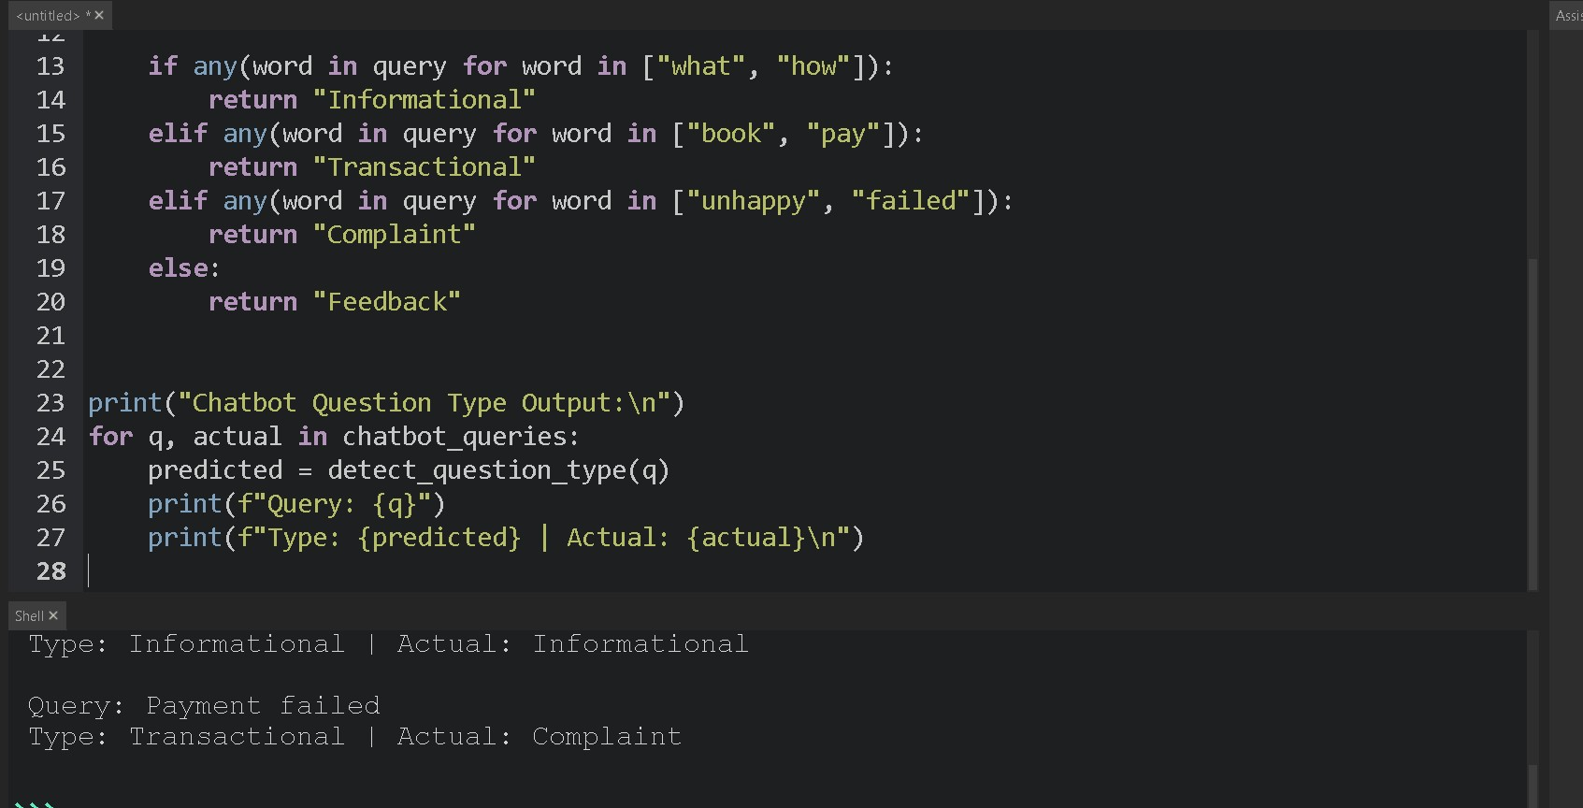
Comparison
- Few-shot handles ambiguous queries better
- Zero-shot may misclassify complaints as informational

Output:
Query: What is the refund policy?
Detected Type: Informational
Actual Type: Informational

Explanation :
Chatbot Question Type Detection
- The program classifies user queries into Informational, Transactional, Complaint, or Feedback.
- A list of chatbot queries with correct labels is used for testing.
- The function detect_question_type() takes a query as input.
- The query is converted to lowercase for consistent comparison.

5. Emotion Detection in Text (Main Question) Emotion Samples emotions = [
("I am feeling great today!", "Happy"),
("I feel very sad and lonely", "Sad"),
("This makes me so angry", "Angry"),
("I am worried about my future", "Anxious"),
("Just another normal day", "Neutral"),
("Feeling stressed and nervous", "Anxious")
]

Python Code (Zero / One / Few Shot Simulation) def emotion_detector(text):
text = text.lower()

if any(word in text for word in ["great", "happy"]):
return "Happy" elif any(word in text for word in ["sad", "lonely"]):
return "Sad" elif any(word in text for word in ["angry", "mad"]):
return "Angry" elif any(word in text for word in ["worried", "nervous", "stressed"]):
return "Anxious"
else:
return "Neutral"

print("Emotion Detection Output:\n") for t, actual in emotions:
predicted = emotion_detector(t)
print(f"Text: {t}") print(f"Emotion: {predicted} | Actual: {actual}\n")

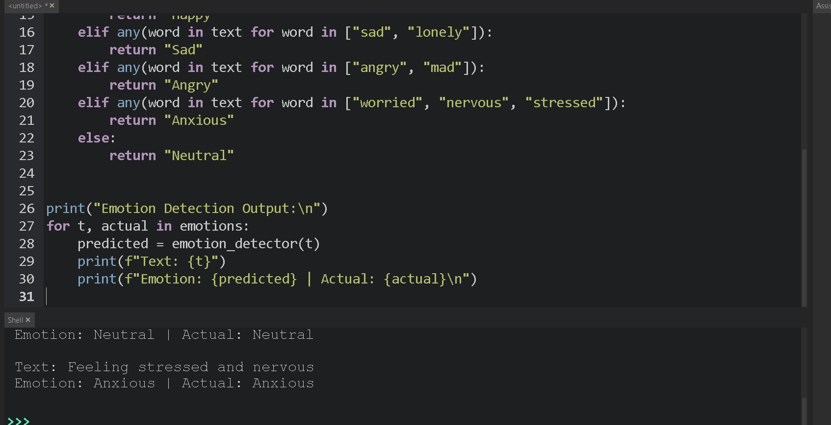
Sample Output
Text: I am worried about my future
Emotion: Anxious | Actual: Anxious

Emotion Detection
- The program detects emotions from text such as Happy, Sad, Angry, Anxious, or Neutral.
- A list of sample texts with actual emotion labels is created for testing.
- The function emotion_detector() takes a text as input.
- The text is converted to lowercase to avoid case mismatch.
- The program checks for specific emotion-related keywords using any().
- If matching keywords are found, the corresponding emotion is returned.
- If no keywords match, the emotion is classified as Neutral.

